Technical Specification

Customer Name : Pars Appliance MFG. CO.

Model Name : LARDER
Twin Ref

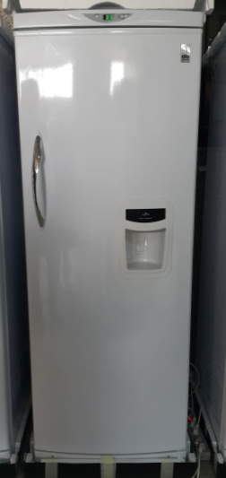

February 11, 2020

Program : PARS_TWIN_REF_(LARDER)_MAIN(20200211).hex

Keys & Function

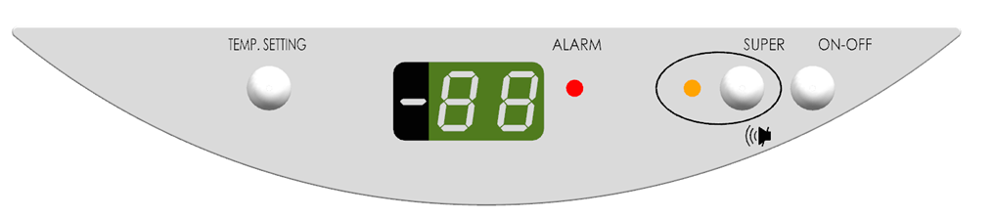

- TEMP.SETTING Setting the Ref Room Temperature (+1℃ ~ +8℃)

- SUPER (Mute) Canceling the Buzzer Sound

- SUPER (3 seconds) Setting the “Super Cooling Mode”

- ON/OFF Power ON/OFF during the Plug-In states
Note>
During the OFF Mode, all Function should be not workable.
(including not checking the Error)

Cf> Dual Keys

- Test Mode “TEMP.SETTING + SUPER ” (5 seconds)

- States Mode (St) “TEMP.SETTING + SUPER + ON/OFF” (5 seconds)

Indicating LED Lamp

- “ALARM” LED Lamp indicating the abnormal working state as like Door Open / Error
Red Color
Blanking ON / OFF
Note>
If the Door is opened for over 60 seconds, the Buzzer Sound becomes activated. (ON 0.5 seconds / OFF 0.5 seconds)

- “SUPER” LED Lamp Indicating the “Super Cooling Mode” activating
Yellow Color
ON / OFF

Displaying Temperature

- “88” Segments indicating the Setting Temperature / Error Code / States Code

Remarks>
During the Cooling mode, the Setting Temperature is displayed.
During the Super Cooling Mode, “SU” is displayed.

Cooling Mode / Setting the Temperature

1. Plug-In & Entering the Cooling Mode

Under the “ON” Setting,
the Refrigerator (Twin Ref : DARDER) is working in accordance with below Cut-In / Cut-Off.

Setting Temp. | Cut-In (Comp ON) Temp  by Eva Sensor | Cut-Off (Comp Off) Temp  by Room Sensor
+1 ℃ | +5 ℃ | 0 ℃
+2 ℃ | +5 ℃ | +1 ℃
+3 ℃ | +5 ℃ | +2 ℃
+4 ℃ | +5 ℃ | +3 ℃
+5 ℃ | +5 ℃ | +4 ℃
+6 ℃ | +5.5 ℃ | +5 ℃
+7 ℃ | +6.5 ℃ | +6 ℃
+8 ℃ | +7.5 ℃ | +7 ℃

2, Displaying the Temperature and Setting the Temperature during the Cooling Mode

- Default Temp : +5 ℃

- During the Cooling Mode, the Setting Temperature is displayed on the Display Panel.

- How to set the Temperature
- Pushing the “Temp” key for 2 seconds
- 5 ℃ -→ 4 ℃ -→ 3 ℃ -→ 2 ℃ -→ 1 ℃ -→ 8℃ -→ 7 ℃ -→ 6 ℃ -→ 5 ℃ -→ 4 ℃
- Blinking in Temp Setting

Remarks>
The latest Setting Temperature is saved even in plug-out.

3, Room LED / Alarm in Door Open

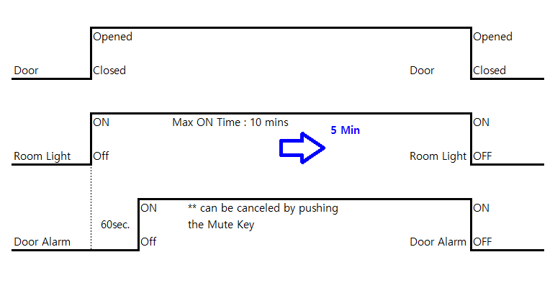

- Room LED ON Max : 5 minutes

- Door Alarm is kept blanking if the Door is continuously opened since 60 seconds later.

- Buzzer Sound becomes ON (ON 0.5 seconds ←-→ OFF 0.5 seconds) with the Door Alarm ON. And it can be canceled by pushing the Mute key. But the canceled Buzzer Sound becomes again ON if the Door is continuously opened. And it will not become again ON until the Door is opened. But the mute Alarm will reset when the Door is closed.

4, Fan Operation

During the Cooling Mode,
Comp ON – Fan ON
Comp OFF – Fan ON 2 minutes / Fan OFF 2 minutes

During the Super Cooling Mode
Com ON – Fan ON

Remarks> Fan and Comp are independent of the door open/close operation.
---→ Fan is dependent of the Door Open/Close operation. (if the Door open, immediately Fan OFF)

Super Cooling Mode

How to enter / terminate

Pushing the Super key for 3 seconds

Operating the Super Cooling Mode

- Continuous Comp ON for 6 Hours until reaching to 1 ℃
(after reaching to +1℃ or passing 6 hours, Super Mode becomes to be finished)
- Yellow LED ON in Super Cooling Mode. “SU” is displayed.
- Once terminating the Super Cooling Mode, the Setting Temp will be returned to the latest Setting Temp.

*** Comp should ON for 6 Hours, for setting Temp +1 ℃

Error Mode

1. Room Sensor Error : Error Code “AF”
- Room Sensor “Open / Short” condition
- Displaying Error code : AF
- Alarm ON with Buzzer Sound ON (ON 1 second ←-→ OFF 1 second).
But Buzzer sound can be OFF by pushing the Mute key.
And it will not become again On Until the Door is opened.
- Comp ON 40 minutes <---> Comp OFF 20 minutes

2. Eva Sensor Error : Error Code “EF”
- Eva Sensor “Open / Short” condition
- Displaying Error code : EF
- Alarm ON with Buzzer Sound ON (ON 1 second ←-→ OFF 1 second).
But Buzzer sound can be OFF by pushing the Mute key.
And it will not become again On Until the Door is opened.
- Comp ON 40 minutes <---> Comp OFF 20 minutes

3. Cooling Error : Error Code “LO”
- Room Temperature is continuously “over +8℃ (as like +9℃) for 10 hours”.
- Displaying Error code : LO
- Alarm ON with Buzzer Sound ON (ON 1 second ←-→ OFF 1 second).
But Buzzer sound can be OFF by pushing the Mute key.
And it will not become again On Until the Door is opened.

Remarks>
Buzzer Sound can be OFF once pushing the Mute key.

Test Mode

How to enter

Pushing the “Temp + Super” keys for 5 seconds
Displaying the “tE” in Test Mode

Auto Test Mode
automatically starting to Test the parts (Comp / Fan / Room Lamp) as below.

- Turning ON 88-Segments for each 1 second interval
- Turning ON LED (RED LED / YELLOW LED) for each 1 second interval
- 5 seconds Delay Time for checking the 3 keys
- Comp ON for 5 seconds
- Fan ON for 5 seconds
- Room Lamp ON for 5 seconds

And then,
Automatically returning to the Normal Cooling Mode

States Mode

How to enter

Pushing the “Temp + Super + ON/OFF” keys for 5 seconds
Displaying the “St” in States Mode,
pushing “Temp” key

Displaying the States in sequence

tA (Room Temperature)
Temp
tE (Eva Temperature)
Temp
CO (Compressor)
ON / -- (OFF)
FA (Fan)
ON / -- (OFF)

How to terminate

Pushing the “Temp + Super + ON/OFF” keys
Or
If no key is pressed after 2 minutes, automatically returning to the normal cooling mode.

